1. **Write a Python program to print "Hello Python"?**

**Ans:**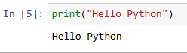

1. **Write a Python program to do arithmetical operations addition and division.?**

**Ans:**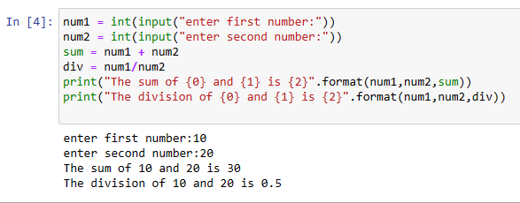

1. **Write a Python program to find the area of a triangle?**

**Ans:**

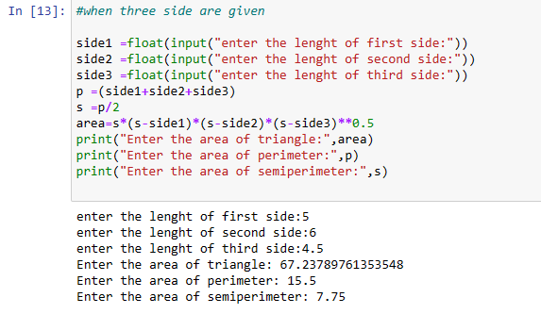

1. **Write a Python program to swap two variables?**

**Ans:**

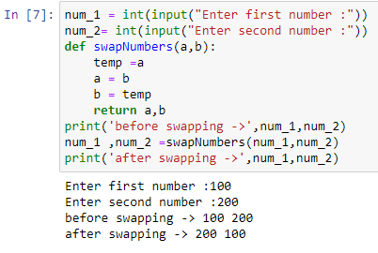

1. **Write a Python program to generate a random number?**

**Ans:**

